A Comparison of Common Users across Instagram and Ask.fm to Better Understand Cyberbullying

Abstract: This paper examines users who are common to two popular online social networks, Instagram and Ask.fm that are often used for cyberbullying. An analysis of the negativity and positivity of word usage in posts by common users of these two social networks is performed. These results are normalized in comparison to a sample of typical users in both networks. We also examine the posting activity of common user profiles and consider its correlation with negativity. Within the Ask.fm social network, which allows anonymous posts, the relationship between anonymity and negativity is further explored.

Dataset:   
Instagram: 41K user ids were gathered with a snowball sampling method.  
About 25K public profiles, these 25K public user profiles are used as our normal Instagram users.

Ask.fm: starting from a seed node and again using snowball sample, 24K were used as the normal Ask.fm users.

We collected 1M users’ information via snowball sampling. Only 4% of the users have mentioned their Instagram id in their profile information, thereby furnishing around 40K user’s ids for both social networks. Only 24K of these profiles were public. From this, we collected complete profile content for an 8K subset of these common users from each of the two social networks, forming our common Instagram user’s data and common Ask.fm user’s data.

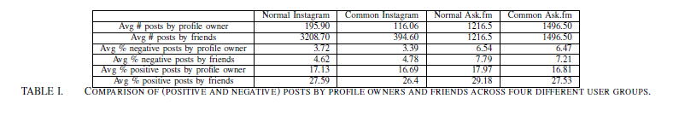

Methodology:

We use Linguistic Inquiry and Word Count (LIWC), and passed to it the four user types we have (normal Instagram users, normal Ask.fm users, common Instagram users and common Ask.fm users)

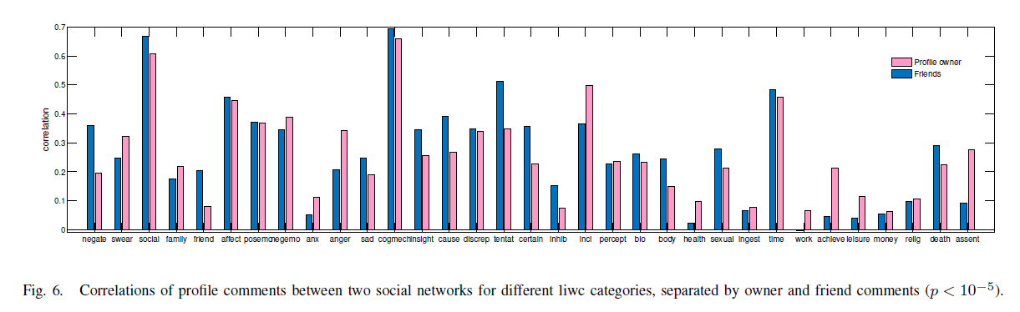

Drawbacks:   
One important feature in a social network that can potentially lead to negative user behavior is anonymity. Intuitively, it seems that if users can post messages anonymously, they will tend to be more negative.